Chinese Painting Workshop  Appreciation of Chinese painting | 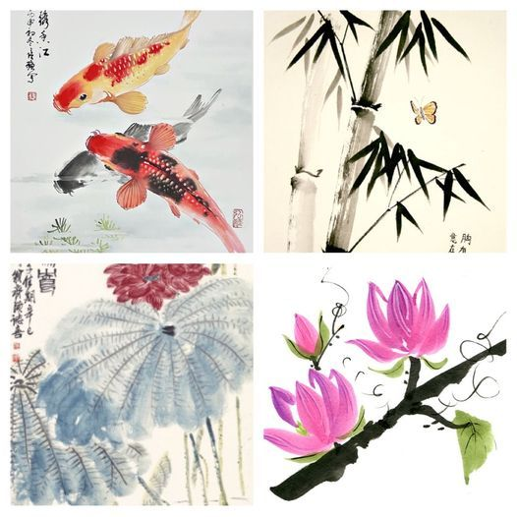
This workshop will cover:
- An introduction to the types of Chinese paintings
- Basic features and constituent elements
- What is considered a good Chinese painting?

Date: | 9 August (Tuesday)
Time: | 1.00pm–3.00pm
Instructor： | William Cai
Venue: | BHMWA Centre
Cost： | £10 per person
Enquiries or sign-up: | Email: enquiry@bhmwa.com (Edith Lau)

