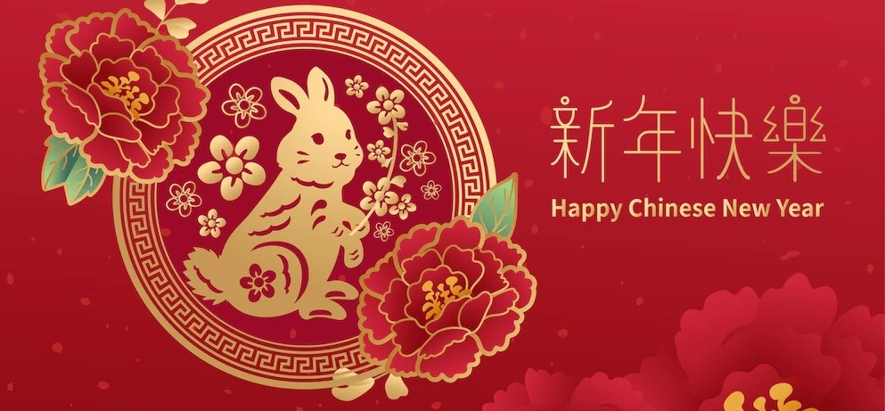

Chinese New Year Lunch
You are welcome to celebrate Chinese New Year with us and usher in the year of the rabbit! Enjoy a delicious lunch at the New Loon Fung Restaurant.

Date: | 20 January 2023 (Friday)
Time: | 1:00pm
Venue | New Loon Fung Restaurant, Chinatown
Cost: | £28 per person
Menu: | Dim sum: har kau, siu mai, spinach dumplings, potstickers, char siu bao, chicken claws, pan-fried radish cake, char siu cheung fun, monk’s vegetarian cheung fun  Main dishes: Stir-fried choi sum with garlic, char siu & roast duck, Yangzhou fried rice, stir fried pork hor fun in black bean sauce
Sign-up: | Email: enquiry@bhmwa.com  Tel: 020 7766 1141  WhatsApp: 07834 611610, Edith Lau

